SUPPORT OUR FUTURE
Order Your Photobook Now!
Celebrating Our History!
P E O P L ES C O N G R E G A T I O N A L U n i t e d C h u r c h o f c h r i s t
Capital Campaign Fundraiser
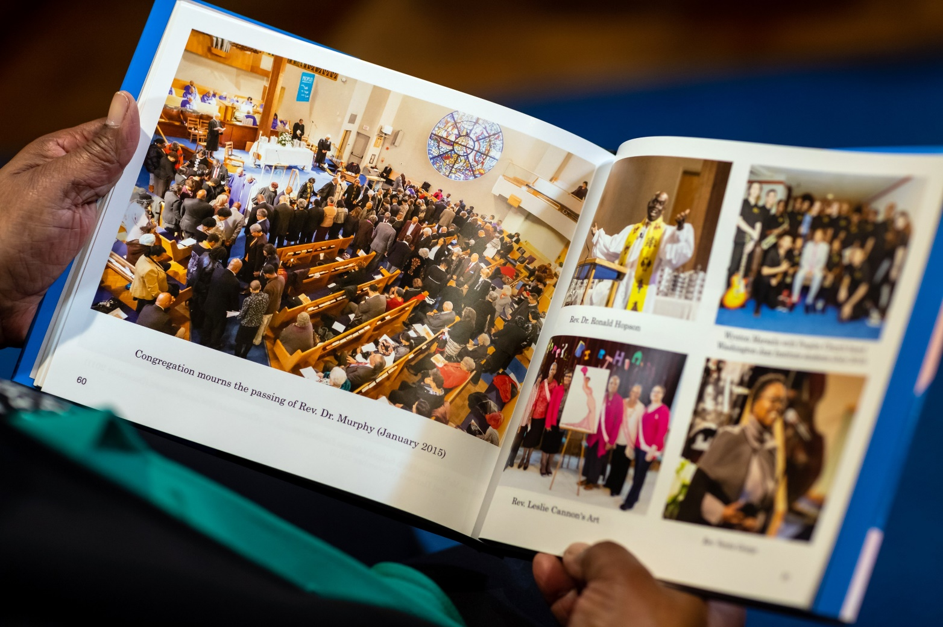
You are invited to our
Reception
After Concert
In Fellowship Hall
You are invited to our
Reception
After Concert
In Fellowship Hall
You are invited to our
Reception
After Concert
In Fellowship Hall
You are invited to our
Reception
After Concert
In Fellowship Hall
You are invited to our
Reception
After Concert
In Fellowship Hall
You are invited to our
Reception
After Concert
In Fellowship Hall
You are invited to our
Reception
After Concert
In Fellowship Hall
Complete this form and return to Peoples Congregational United Church of Christ
Make checks payable to Peoples Church and place 130th Photo Book & # of Copies on the Memo Line

Your Name: ________________________________ Phone Number: _______________

Street Address: ___________________________ City, State: _____________________
Prices: One Book $75 - Each additional book with same Order $70

One Book $75 _______ Two Books $145 _____ Three Books $215 ______
Photo Books may be picked up at the church once they arrive!
4704 13th Street, NW Washington, DC 20011

